**2A2B HUMAN BIOLOGY METABOLISM TEST**

Name:_____________________________ /33

Part one – Multiple Choice

**1.** Metabolism is:

a) a measure of how efficiently the body can burn fat.

b) the total of all reactions in the body that break down larger molecules into smaller ones

c) the combining of small molecules to make larger ones

d) the total of all chemical reactions that take place within the cells of an organism

**2.** Which of the following statements is **correct**

a) Synthesis is an anabolic reaction

b) Synthesis is another word for metabolism

c) Synthesis is a catabolic reaction

d) Synthesis is the joining of amino acids with peptide bonds for form proteins.

**3.** Enzymes lower ___________________ to enable chemical reactions to happen at a lower temperature.

a) Cell activity

b) Cytoplasm production

c) Activation energy.

d) Blood pressure

**4.** In the process of cellular respiration there is a release of:

a) Glucose

b) Energy

c) Carbohydrates

d) Oxygen

**5.** Which of the following may function as co-factors for enzymes?

a) Vitamins

b) Minerals

c) Vitamins and minerals

d) Neither vitamins nor minerals

**6.** Enzymes are made of

a) Proteins

b) Glucose

c) Carbohydrates

d) Lipids

**7.** Anaerobic respiration

a) Necessitates the use of recovery oxygen afterward

b) Always occurs during physical activity

c) Results in the production of Pyruvic Acid which can cause muscle pain

d) Results in a glucose debt which must be repaid in the liver

**8.** Which of the following is **false** about Lipids

a) Lipids can be broken down into glycerol and fatty acids

b) Lipids are an important source of energy

c) Lipids can be broken down into glycerol which can be used in glycolysis like glucose

d) Lipids can act as co-factors for enzymes

9. Which of the following shows the correct distribution of energy produced during cellular respiration?

|  |  |  |
| --- | --- | --- |
|  | Heat % | ATP % |
| a | 60 | 40 |
| b | 50 | 50 |
| c | 40 | 60 |
| d | 20 | 80 |

Part 2 - Short Answer

1. On the diagram of a cell below, mark in and label where cellular respiration occurs. (2 marks)

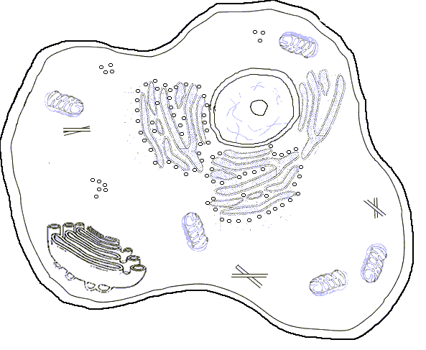

**2.** List 4 uses of energy within the cell (2 marks)

**3.** Using a diagram show the relationship between ATP and ADP (4 marks)

**4.** Explain how enzymes work, draw a labelled diagram below to help with your explanation. (4 marks)

5. Explain two factors which may affect enzyme function (4 marks)

Part Three - Extended Answer

Explain the differences and similarities between aerobic and anaerobic respiration (8 marks)

**2A2B HUMAN BIOLOGY METABOLISM TEST**

Name:SOLUTIONS___ /33

Part one – Multiple Choice

**1.** Metabolism is:

a) a measure of how efficiently the body can burn fat.

b) the total of all reactions in the body that break down larger molecules into smaller ones

c) the combining of small molecules to make larger ones

d) the total of all chemical reactions that take place within the cells of an organism

**2.** Which of the following statements is **correct**

a) Synthesis is an anabolic reaction

b) Synthesis is another word for metabolism

c) Synthesis is a catabolic reaction

d) Synthesis is the joining of amino acids with peptide bonds for form proteins.

**3.** Enzymes lower ___________________ to enable chemical reactions to happen at a lower temperature.

a) Cell activity

b) Cytoplasm production

c) Activation energy.

d) Blood pressure

**4.** In the process of cellular respiration there is a release of:

a) Glucose

b) Energy

c) Carbohydrates

d) Oxygen

**5.** Which of the following may function as co-factors for enzymes?

a) Vitamins

b) Minerals

c) Vitamins and minerals

d) Neither vitamins nor minerals

**6.** Enzymes are made of

a) Proteins

b) Glucose

c) Carbohydrates

d) Lipids

**7.** Anaerobic respiration

a) Necessitates the use of recovery oxygen afterward

b) Always occurs during physical activity

c) Results in the production of Pyruvic Acid which can cause muscle pain

d) Results in a glucose debt which must be repaid in the liver

**8.** Which of the following is **false** about Lipids

a) Lipids can be broken down into glycerol and fatty acids

b) Lipids are an important source of energy

c) Lipids can be broken down into glycerol which can be used in glycolysis like glucose

d) Lipids can act as co-factors for enzymes

9. Which of the following shows the correct distribution of energy produced during cellular respiration?

|  |  |  |
| --- | --- | --- |
|  | Heat % | ATP % |
| a | 60 | 40 |
| b | 50 | 50 |
| c | 40 | 60 |
| d | 20 | 80 |

Part 2 - Short Answer

1. On the diagram of a cell below, mark in and label where cellular respiration occurs. (2 marks)

Mitochondria and Cytoplasm must be correctly labelled and identified to receive one mark each

**2.** List 4 uses of energy within the cell (2 marks)

Any four of the following (can’t list any of the ones on the same line separately

* Building complex molecules – anabolism – synthesis
* Cell division and growth
* Movement of cell organelles
* Movement of whole cell
* Maintaining cell organisation
* Active transport or any of the examples of active transport
* Transmission of nerve impulses

**3.** Using a diagram show the relationship between ATP and ADP (4 marks)

* Diagram should show a cycle
* Show energy in and energy out in correct place
* ADP, ATP and P labelled correctly
* High energy bond shown

**4.** Explain how enzymes work, draw a labelled diagram below to help with your explanation. (4 marks)

* Diagram should have labels as below (1/2 mark each label) 2
* Suitable explanation of diagram 2

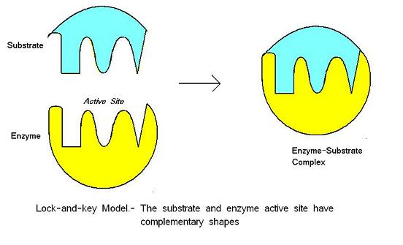

5. Explain two factors which may affect enzyme function (4 marks)

|  |  |
| --- | --- |
| Temperature | Higher = faster to a point |
| pH | Each has their optimum |
| Concentration | Higher = faster to a point |
| Co-Factors | Must be present for some enzymes to work |
|  |  |

One mark for the factor, one for the explanation

Any 2

Part Three - Extended Answer

Explain the differences and similarities between aerobic and anaerobic respiration (8 marks)

|  |  |
| --- | --- |
| **Anaerobic** | **Aerobic** |
| No Oxygen required | Oxygen required |
| Glycolysis first step or Pyruvic acid first substrate or starts with glucose | Glycolysis first step or Pyruvic acid first substrate or requires clucose |
| Cytoplasm | Mitochondria |
| 2 ATP | Up to 38ATP |
| Incurs oxygen debt / requires recovery oxygen | No oxygen debt / no recovery oxygen required |
| Produces lactic acid | Produces CO2 and water |
| Products cause muscle pain | Products do not cause muscle pain |
| Occurs only rarely in certain cells | Occurs most of the time in all cells |
|  |  |
|  |  |